10.3 Unit Circle Trigonometry

**Review:**

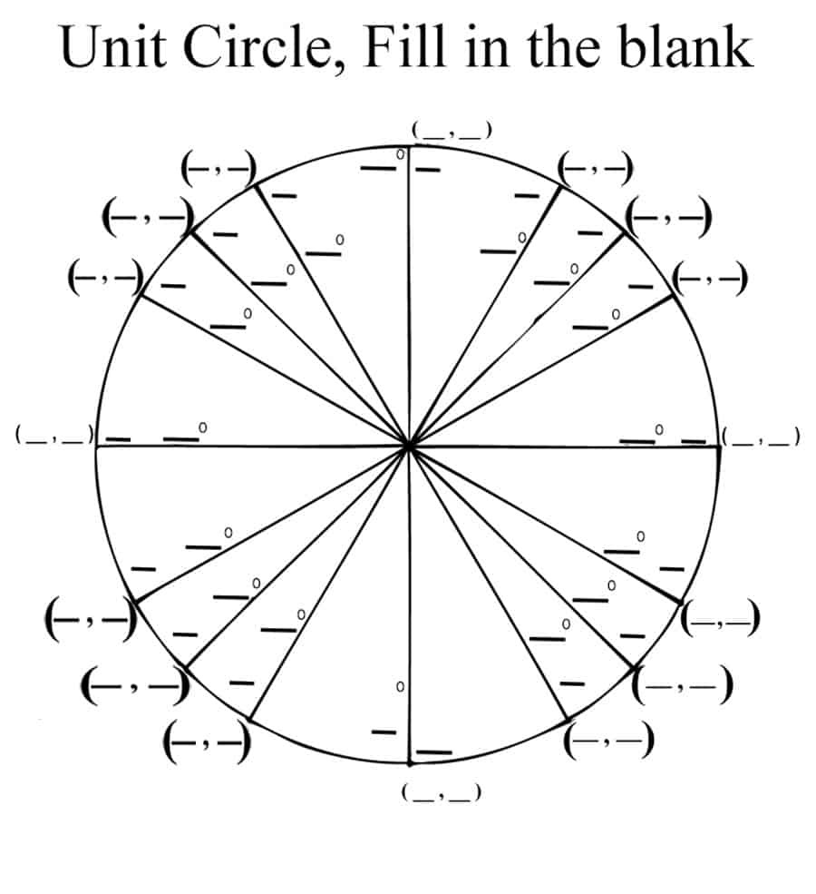

**B**

1. Which letter represents the angle of 0 degrees/radians?

**A**

**D**

1. Which letter represents the angle of 90 degrees/

$\frac{π}{2}$ radians?

**C**

1. What are the coordinates at letter A?

Fill in the blanks with the following word bank (some can be used multiple times)

Hypotenuse Adjacent Opposite

X-coordinate Y-coordinate 1

$$\sin\left(θ\right)= ____________________=_____________________$$

$cos⁡(θ)= ___________________=_____________________$

$$tan⁡(θ)= ___________________=_____________________$$

Circuit Training:

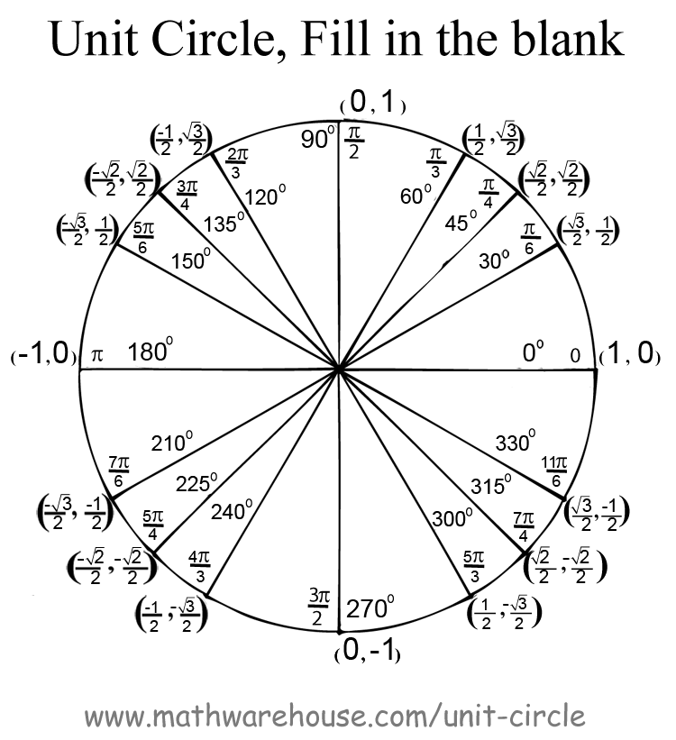

|  |  |
| --- | --- |
| $sin⁡(120°)$ | 2. $tan⁡(135°)$ |
| 3. $\sin\left(90°\right)$ | 4. $cos⁡(300°)$ |
| 5. $\sin\left(\frac{11π}{6}\right)$ | 6. $\cos\left(\frac{3π}{4}\right)$ |
| 7. $\tan\left(\frac{5π}{3}\right)$ | 8. $sin⁡(\frac{7π}{4})$ |
| 9. $\tan\left(150°\right)$ | 10. $\cos\left(π\right)$ |
| 11. $\tan\left(0\right)$ | 12. $\tan\left(\frac{π}{2}\right)$ |
| 13. $\cos\left(270°\right)$ | 14. $\sin\left(270°\right)$ |
| 15. $\tan\left(\frac{4π}{3}\right)$ | 16. $\sin\left(\frac{7π}{6})\right)$ |

**Extension/Extra Credit Task**: Work with your group to graph the functions $y=sin⁡(x)$. Label your y- and x-axis.

(hint: find coordinates of the graph as you would any other function)